Experiment No. 9
Autoencoder for Image Denoising
Name : Rishabh Ramani
Class : D15B
Roll No : 48
Batch : B

Aim
To implement an Autoencoder neural network for image denoising using the MNIST dataset, and compare baseline vs tuned model performance.

1. Dataset Source
Dataset Name: MNIST Dataset
The MNIST dataset consists of 70,000 grayscale images of handwritten digits (0-9), each of size 28×28 pixels.

2. Dataset Description
- Total images: 70,000 (60,000 training + 10,000 testing)
- Image size: 28×28 pixels
- Color space: Grayscale (Single channel)
- Input: Noisy images (Gaussian noise added)
- Output: Reconstructed clean images

3. Theory - Autoencoder
An Autoencoder is an unsupervised neural network that learns to compress (encode) data into a latent representation and then reconstruct (decode) it. It consists of:
- Encoder: Compresses the input into a lower-dimensional latent space
- Latent Space (Bottleneck): The compressed representation
- Decoder: Reconstructs the original data from the latent representation
For denoising, noisy images are fed as input and the network learns to output clean images.

4. Mathematical Formulation
Encoder: z = f(Wx + b)
Decoder: x̂ = g(W'z + b')
Loss Function (MSE): L = (1/n) Σ ||xᵢ - x̂ᵢ||²

Evaluation Metrics:
- MSE (Mean Squared Error): Pixel-level accuracy
- PSNR (Peak Signal-to-Noise Ratio): Signal clarity
- SSIM (Structural Similarity Index): Structural preservation

5. Algorithm Limitations
- Autoencoders may blur fine details during reconstruction
- Performance depends on the size of the latent space
- May not generalize to noise types not seen during training
- Deeper models require more data and computation

6. Methodology / Workflow
- Load MNIST dataset
- Add Gaussian noise to images
- Normalize pixel values to [0, 1]
- Build baseline Autoencoder architecture
- Train on noisy images with clean targets
- Evaluate using MSE, PSNR, SSIM
- Build tuned Autoencoder with deeper architecture
- Compare performance of both models

7. Baseline Autoencoder
Model Summary:
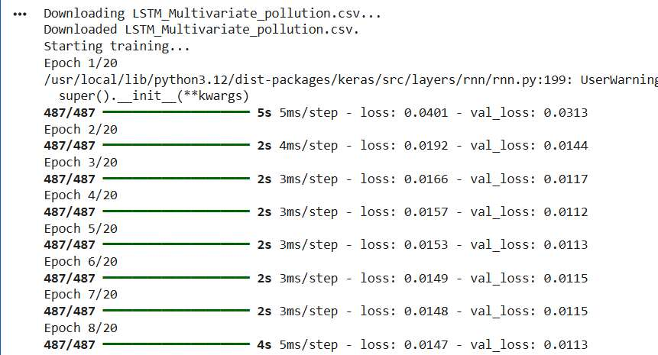

Training Loss:
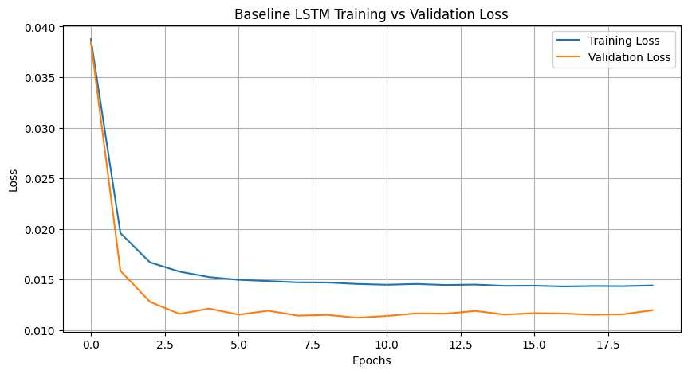

Baseline Denoising Results (Original / Noisy / Denoised):
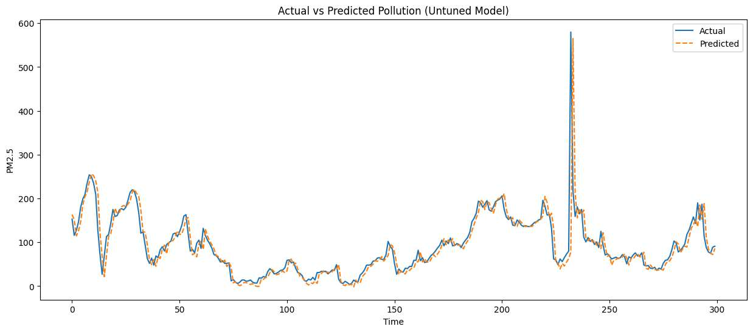

8. Performance Analysis
Baseline Model:
- MSE: 0.1147
- PSNR: 9.70 dB
- SSIM: 0.2359

Tuned Model:
- MSE: 0.0126 (~89% improvement)
- PSNR: 19.31 dB
- SSIM: 0.8418
This shows major improvement in pixel accuracy, signal clarity, and structural preservation.

9. Hyperparameter Tuning
input_dim = 784 # 28*28
hidden1_tuned = 256
hidden2_tuned = 128
latent_dim_tuned = 32 # Smaller latent space to force more compression

# Encoder for tuned model
input_img_tuned = Input(shape=(input_dim,))
encoded_tuned = Dense(hidden1_tuned, activation='elu')(input_img_tuned)
encoded_tuned = Dense(hidden2_tuned, activation='elu')(encoded_tuned)
encoded_tuned = Dense(latent_dim_tuned, activation='elu')(encoded_tuned)

# Decoder for tuned model
decoded_tuned = Dense(hidden2_tuned, activation='elu')(encoded_tuned)
decoded_tuned = Dense(hidden1_tuned, activation='elu')(decoded_tuned)
decoded_tuned = Dense(input_dim, activation='sigmoid')(decoded_tuned)

autoencoder_tuned = Model(input_img_tuned, decoded_tuned)
autoencoder_tuned.compile(optimizer=Adam(learning_rate=0.0005), loss='mean_squared_error')

history_tuned = autoencoder_tuned.fit(x_train_noisy, x_train, epochs=10, batch_size=256,
shuffle=True, validation_data=(x_test_noisy, x_test))

Output - Tuned Model Summary:
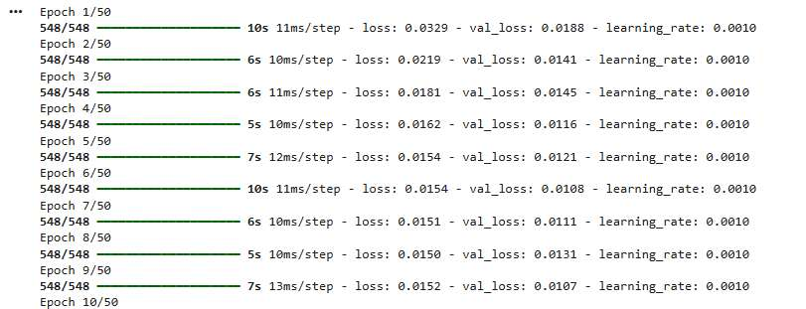

Output - Tuned Model Training Loss:
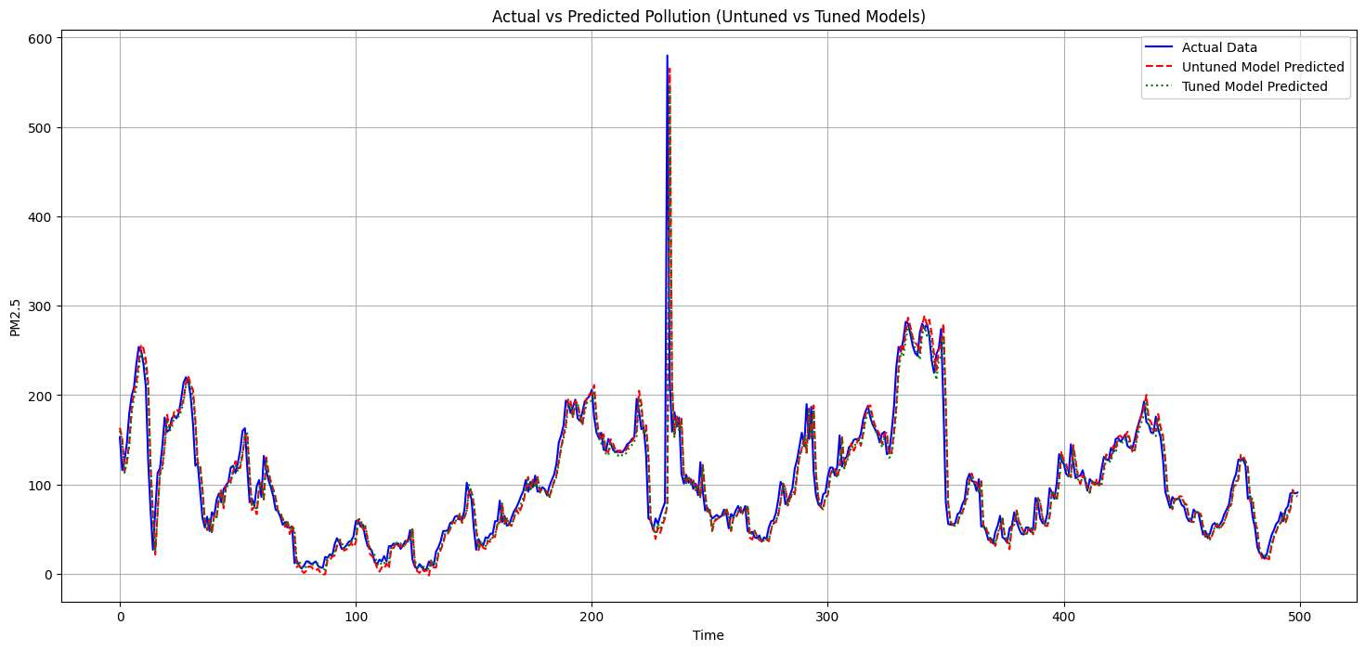

Output - Tuned Denoising Results:
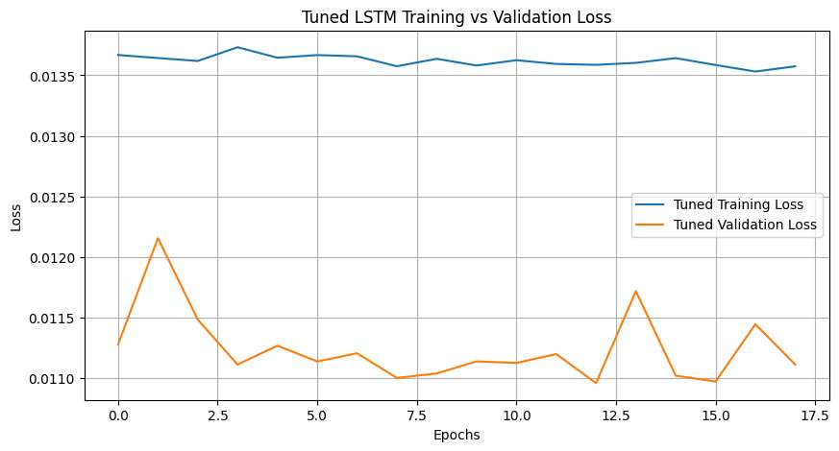

Conclusion
The Autoencoder successfully denoised MNIST images. The tuned model significantly outperformed the baseline, with SSIM improving from 0.2359 to 0.8418 and PSNR nearly doubling. Deeper architectures with smaller latent spaces force more meaningful compression and reconstruction.

